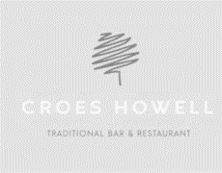
Available Monday to Thursday 12-9pm
Fridays 12-4pm

TWO COURSES £15 OR 3 COURSES £18

Starters
Garlic Bread & Cheese
Balsamic glaze
Sticky sausages (*)
Mini sticky sausages, garlic mayonnaise
Camembert Cheese Bites
Chilli jam
Salt & pepper cauliflower bites
Sweet chilli sauce

Mains
Southern fried chicken burger  cheese, lettuce, tomato & skin on fries  Hunters chicken ciabatta  Toasted garlic ciabatta, BBQ chicken breast, bacon, cheese, skin on fries | Margarita pizza (VG)  Skin on fries  Mini fish & chips (*)  Hand cut chips, mushy peas, tartar sauce, lemon wedge

Desserts

Selection of ice cream or sorbet (*)
Choice of 2 scoops
Salted caramel Cheesecake
Vanilla ice cream
Chocolate fudge cake
Vanilla custard
Lemon posset

Berry compote, whipped cream

If you have any dietary requirements, then please ask a member of staff for more information.
(gf) denotes a dish is gluten free |* denotes it can be prepared gluten free |(vg) denotes a dish is vegetarian | (+) denotes the dish can be prepared vegan. All items are subject to availability. 3824190

