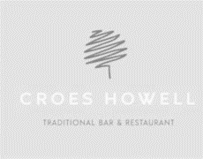

The VIK Menu

Mains £7
Cheeseburger, skinny fries (*)
Chicken goujons, skinny fries, baked beans (*)
Tomato pasta, grated cheese
Fish Fingers, skinny fries, baked beans (*)
Kids Roast – Beef, Gammon, turkey or nut roast (Sundays Only)

Puddings £4.00
Sticky toffee pudding, vanilla ice cream
2 scoops of Welsh vanilla ice cream (*)

We also have a selection of cordials & soft drinks or mocktails… ask the staff for more details!!

We Love our Football!!
Who is your favourite player!!..........................................................................

Why not colour him in? Add some colour as long as it’s not blue!!!
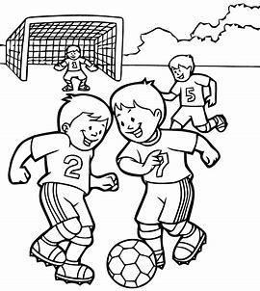
A | S | O | B | R | O | W | N | I | E | Can you find them all?
F | A | O | D | I | O | C | H | A | W | They can be diagonal, horizontal
G | U | E | D | D | L | O | U | R | W | or vertical
H | S | Y | F | A | T | C | I | A | D
N | A | A | A | L | U | K | X | L | A
J | G | O | T | Y | P | T | Z | K | F
U | E | B | B | H | O | A | C | J | R | Pie
I | S | P | O | N | I | I | V | H | E | Fishnchips
K | L | P | A | U | U | L | B | G | S | Juice
L | K | U | R | J | Z | S | E | E | H | Fatboar
J | R | T | Z | M | U | Y | I | R | E | Brownie
P | U | F | F | I | J | R | R | T | A | Ice
E | F | I | J | K | F | A | J | T | O | Cream
E | E | R | C | L | Q | U | S | V | I | Sausages
W | E | X | C | E | J | A | J | C | U | Fresh
Q | D | R | T | U | P | L | R | W | L | Fries
S | D | Y | U | I | O | D | M | F | K | Pasta
I | P | I | E | Y | I | M | L | P | L
C | R | H | Y | U | C | R | E | A | M | Can you do it in under 5 minutes??
D | R | O | N | I | E | J | K | O | P
Q | T | Y | P | L | I | K | Y | U | M
F | I | S | H | N | C | H | I | P | S

